Equine Goods and Services Directory 2016

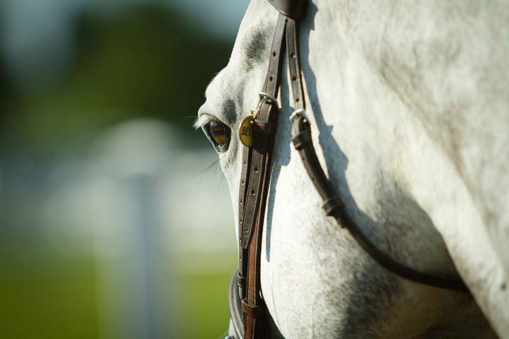

Southern Illinois Equine Committee

This directory is brought to you as a service of the Southern Illinois Equine Committee. The Southern Illinois Equine Committee was formed to bring together equine enthusiast in Southern Illinois. The purpose of the group is to promote and protect the economic well-being of the equine industry in Southern Illinois by facilitating, educating, informing and communicating with the equine industry.

The equine industry represents a large portion of the agricultural economy in Southern Illinois and the committee is striving to support this industry by providing various programs and services. Make sure to watch for upcoming events and workshops designed especially for equine enthusiasts!

If you have specific concerns, please feel free to contact your local county Farm Bureau.

Gallatin County
Phone: 272-3531
Email: gcfarm@swohio.twcbc.com

Jackson County
Phone: 684-3129
Email: jacksonfb@frontier.com

Johnson County
Phone: 658-2871
Email: johnsoncountyfb@frontier.com

Massac County
Phone: 524-5811
Email: mcfb@frontier.com

Pope-Hardin County
Phone: 683-3651
Email: phfb@shawneelink.net

Pulaski-Alexander County
Phone: 745-9429
Email: pafb@mchsi.com

Saline County
Phone: 252-6992
Email: salcofb@gmail.com

Union County
Phone: 833-2125
Email: unionfb@frontier.com

Williamson County
Phone: 993-2609
Email: wcfb@aol.com

Feed/Bedding/Hay/Mineral Supply
Feed-
Bedding-
Alstate Wood Products
826 Hwy 13-127, Duquoin, IL 62832
Phone: 1-618-684-5167
Email: alstatwoodproducts@gmail.com

Boarding/Training/Lessons
Boarding
McNana Farms
259 E. Haney Rd, Carbondale IL 62901
Phone: 1-618-559-2404
Email: rikkimcnan@yahoo.com
Indoor/Outdoor arenas extra large 12x16 stalls, grass turnouts, automatic fly spray system, tribute feeds close to SIU

Boarding
Unbridled Memories Ranch, Inc
1644 Milligan Hill Road, Alto Pass, Illinois 62905
Phone: 1-618-444-0768
Email: sigridulrich@unbridledmemoriesranch.com
Find them on Facebook & Instagram
Our barn has 16 horse stalls, an 85’ x 200’ indoor riding arena, a 150’ outdoor arena and a 40’ breaking pen. Our 23 acres is mostly pasture with a small wooded area and a pond.

Lessons
RodeoKat’s Riding Lessons & More
Kaitlin McWhorter
Address: 105 Bethel Church Rd, Cobden, IL 62920
Phone: 1-618-697-72309
Email: kmcwhorter16@gmail.com
Website: www.rodeokat.com
Facebook: RodeoKat’s Rding Lessons & More
Open: Sunday-Saturday 8 am – 5 pm
Full-service horse business- Private/group lessons, horse camps, horse training, birthday parties and rodeo event lessons/clinics

Camp / Ranch
TK Ranch Campground
584 Lusk Road, Golconda, IL 62938
Phone: Kenny- 1-618-922-3925
Terri – 1-618-694-7659
Email: tkranchcampground@gmail.com
Website: tkranchcampground.com
Like us on facebook: TK Ranch Campground
½ mile from One Horse Gap on Lusk Road

General Mechanize(Clothing,Fencing,Equipment,Trailer)/ Auction Services
Jim and Dot’s Shoe Store & Western Wear, INC
113 W Davie St, Anna, IL 62906
Phone: 1-618-833-5245
Email: Jimndots1@hotmail.com
www.jimanddots.com
Like us on facebook: Jim Dots
Open Tuesday – Saturday 9-5
Work boots, work clothes, western wear & jewelry

McKinney’s Western Store
802 Halfway Road, Marion, IL 62959
(618) 997-6974 or (800) 897-9819
mckinneyswesternstore@clearwave.com
Like us on Facebook!

Farrier Service/Veterinarians/Health Care
Ashley Bremer
Certified Equine Massage Therapist
Message from Ashley – I am not a licensed professional; always consult your veterinarian if you have concerns-
4402 Rosebud Rd, Metropolis IL 62960
(618) 638-8772
Ashley.bremer88@gmail.com

